**Wagner Group & Human Rights Violations**

**Amir Haviv**

Human rights violations are highly worrying issues that frequently occur in the shadows, away from the public eye. It is not commonplace for misinformation, propaganda, or a lack of access to correct data to mask the real scope of such acts. As responsible global citizens, we must study and determine the truth underlying these allegations before reaching any conclusions. The Wagner Group has been constantly scrutinized as we navigate the complicated world of human rights. The Wagner Group, a private military organization with close ties to the Russian government, has been implicated in a number of wars throughout the world. They operate in secret, with little to no control or responsibility, raising concerns about human rights violations. While our audience is already familiar with this enigmatic organization, it is crucial to remember that the reality behind their acts is multifaceted and necessitates serious, in-depth investigation to completely comprehend their influence on human rights.

I began this five-week project by immersing myself in the world of the Wagner Group. As a history minor in my bachelor's degree and being from a country where terror attacks are unfortunately common, I found this topic fascinating and chose to undertake my own study. To obtain thorough knowledge, I began by reading various articles from sources such as the UN and Aljazeera, as well as watching relevant YouTube videos. After gathering enough evidence, I was certain that there was a strong link between human rights violations and the Wagner Group. To begin my project, I had to choose between using an API and web scraping to collect data. Despite knowing that an API would be more beneficial, I struggled to work with it and instead chose web scraping.

My primary aim for this research was to produce a heatmap highlighting the countries where the Wagner Group may have violated human rights. To do so, I needed to first identify their most recent foreign operations. I went to Wikipedia to get a detailed timeline of events, including details on deaths, dates, and countries involved. I created a separate table to combine all events taking place within the same country after importing the data on the Wagner Group's operations abroad. This phase was critical in enabling a more efficient data analysis. I created a separate table to combine all events taking place within the same country after importing the data on the Wagner Group's operations abroad. This phase was critical in enabling a more efficient data analysis.

By doing so, I organized the events by country and identified the total number of operations, deaths, and other pertinent statistics for each. This method not only streamlined the data but also presented a clearer picture of the Wagner Group's presence in each location. By aggregating the data in this way, I was able to quickly assess the scope of their actions and their potential impact on human rights violations in various countries. This unified table provided a good framework for creating the heatmap, which sought to highlight the locations where the Wagner Group's operations were most concentrated and potentially linked to human rights crimes.

I used Python modules such as geopandas, numpy, and matplotlib to construct two heatmaps connected to the Wagner Group's activities for this project. I began by importing the required libraries, which were geopandas for processing geographic data, numpy for numerical computations, and matplotlib for generating heatmaps.

To make the first heatmap, I started using geopandas, which gives a low-resolution dataset called 'naturalearth_lowres' that contains geometries and basic information about countries. I then linked the country_counts (as shown in the table above) to the global map data, matching nations by name and filled up any gaps with zeros. With the data in place, I visualized the world's map data in red using matplotlib. I improved the visualization by adjusting the figure size, line widths, and edge colors, and I added a title to the heatmap, which indicates the frequency of Wagner Group operations by country.

I sorted the war data by nation and calculated the sum of casualties for each to prepare for the second heatmap, which shows the number of Wagner Group casualties by country (in thousands). Similarly, to the first heatmap, I integrated the nation casualties data with the world's map data, matching countries by name. Following that, I added a new column to the world data frame called 'is_russia', which determines if each country is Russia or not by performing a simple conditional check with NumPy's where function. Finally, I used matplotlib to build the second heatmap, which displayed the amount of Wagner Group casualties per country on a blue color map. To separate Russia from the other countries, I selected a distinct hue. I changed the scale of the figure, the line widths, and the edge colors, added a title, and plotted the heatmap.

After concluding that my initial investigation was not good enough, I started to look into suspected human rights violations related to the Wagner Group. To accomplish this, I went web scraping, searching for phrases connected to human rights violations such as "violation," "abuse," "torture," "persecution," and "discrimination." After collecting this information, I built a table that summarized the number of times each keyword was found on the various websites. The findings revealed that the phrases 'violation' and 'abuse' were often used, appearing in nearly every story about the Wagner Group. This predominance indicates that human rights violations are a key theme in the group's activity.

In contrast, I also looked for instances of the word 'discrimination', but it appeared that this term was not common in articles discussing the Wagner Group's operations. Consequently, it seems that discrimination may not be a major issue associated with their activities. The results of this web scraping function show that human rights violations, notably abuse, and violations, are regularly mentioned in relation to the Wagner Group. This material lends credence to the allegation that the group was involved in such actions, necessitating additional inquiry.

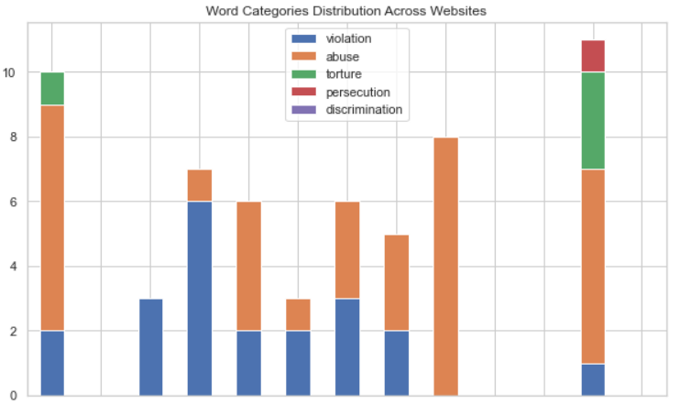

To display the distribution of keyword categories among the websites I looked at, I created a stacked bar chart using the Seaborn and Matplotlib packages. I started by making the chart's background a white grid, and then I changed the data frame to utilize the 'website' column as its index, which made it easy to plot the data with the website names on the x-axis. I then chose the columns that corresponded to the keyword categories ('violation,' 'abuse,' 'torture,' 'persecution,' and 'discrimination') and created a bar chart with them, directing that it be stacked and altering the figure size for greater visualization. Finally, I labeled the axes, gave the chart a title, and rotated the x-axis labels to make them more legible. This graphic helped me comprehend the frequency of each term category in stories about the Wagner Group's activity.

In my future projects, I will prioritize using APIs due to their efficiency in gathering data. APIs provide a direct and streamlined way to access structured data, which greatly reduces the time and effort required for data extraction. Since APIs are designed to provide developers with a stable and well-documented interface for data retrieval, the information obtained through APIs is generally more accurate and up to date compared to web scraping. APIs also offer superior filtering and querying options, enabling users to request specific data points that are relevant to their research, rather than having to sift through a large volume of information. This not only saves time but also reduces the number of computational resources and preprocessing needed to clean and prepare the data for analysis.

Moreover, using APIs mitigates the risk of encountering issues caused by changes in website layouts or structures, which can frequently break web scraping scripts. As a result, relying on APIs for data gathering ensures a more stable and efficient data collection process. By focusing on API usage, I will be able to access more reliable and accurate data while significantly enhancing the overall efficiency of my data gathering efforts.